# **Upload attachments to KM Portal using Outlook Add-In**

Using an Outlook add-in, user can upload attachments directly to KM portal. User can upload all attachments or one attachment at a time. Uploaded document(s) will be updated with the metadata information provided.

We have deployed Add-in to Outlook using Visual Studio.

Tools used

1. Visual Studio 2017

Steps

1. Create Manifest file and deployed through Visual Studio
2. Create Web Application
3. Create Service Application

**1. Create Manifest file and deploy**

You can create Outlook Add-In using Visual Studio.

**File** -> **New** -> **Project** -> **Office/Sharepoint** -> **Outlook Web Add-In**

(Refer Appendix section for sample Manifest file)

Inside the manifest file, you have to change below properties.

1. Change the ID

**<Id>72F77162-7D8A-4009-BFC5-5918075D780C</Id>**

1. Change the display name, description and Icon URL of the AddIn

**<DisplayName DefaultValue="Submit to KMP" />**

**<Description DefaultValue="Submit attachments to NYL KMP"/>**

**<IconUrl DefaultValue=**[**https://nylo365addinsonazure.azurewebsites.net/Images/icon64.png**](https://nylo365addinsonazure.azurewebsites.net/Images/icon64.png) **/>**

1. SourceLocation- Here you can set the Form url that needs to be displayed in outlook add-in pane.

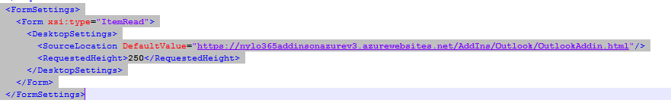

1. Set Image icon Urls, Form Urls and Action properties

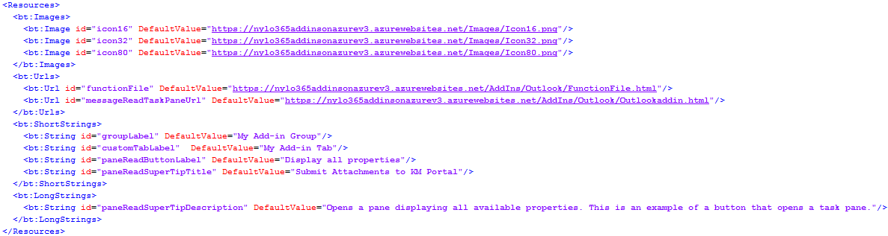

**2. Create Web Application**

Web application will be used to host the Display form, which will capture meta data information about the attachments. User can send attachments one by one or all at a time.

Once user submits the Form, metadata and attachment content will be sent to the web service. In the manifest file, you will set this Display form Url of the web application.

**3. Create Outlook Service controller**

Web service application is used to receive data from web application and send them to SharePoint Online library using CSOM code. You can create visual studio Web API template project for this Service application.

**Appendix:**

**Sample manifest file for Outlook-Addin**

<?xml version="1.0" encoding="UTF-8"?>

<!--Created:ce44715c-8c4e-446b-879c-ea9ebe0f09c8-->

<OfficeApp

xmlns="http://schemas.microsoft.com/office/appforoffice/1.1"

xmlns:xsi="http://www.w3.org/2001/XMLSchema-instance"

xmlns:bt="http://schemas.microsoft.com/office/officeappbasictypes/1.0"

xmlns:mailappor="http://schemas.microsoft.com/office/mailappversionoverrides/1.0"

xsi:type="MailApp">

<!-- Begin Basic Settings: Add-in metadata, used for all versions of Office unless override provided. -->

<!-- IMPORTANT! Id must be unique for your add-in, if you reuse this manifest ensure that you change this id to a new GUID. -->

<Id>FF750F2B-DD55-49F2-9FDF-6C1B79BB9265</Id>

<!--Version. Updates from the store only get triggered if there is a version change. -->

<Version>1.0.0.0</Version>

<ProviderName>[Provider name]</ProviderName>

<DefaultLocale>en-US</DefaultLocale>

<!-- The display name of your add-in. Used on the store and various places of the Office UI such as the add-ins dialog. -->

<DisplayName DefaultValue="Upload to KMP" />

<Description DefaultValue="Upload to KMP Description"/>

<SupportUrl DefaultValue="http://www.contoso.com" />

<!-- Domains that will be allowed when navigating. For example, if you use ShowTaskpane and then have an href link, navigation will only be allowed if the domain is on this list. -->

<AppDomains>

<AppDomain>AppDomain1</AppDomain>

<AppDomain>AppDomain2</AppDomain>

<AppDomain>AppDomain3</AppDomain>

</AppDomains>

<!--End Basic Settings. -->

<Hosts>

<Host Name="Mailbox" />

</Hosts>

<Requirements>

<Sets>

<Set Name="Mailbox" MinVersion="1.1" />

</Sets>

</Requirements>

<FormSettings>

<Form xsi:type="ItemRead">

<DesktopSettings>

<SourceLocation DefaultValue="https://nylo365addinsonazurev3.azurewebsites.net/AddIns/Outlook/OutlookAddin.html"/>

<RequestedHeight>250</RequestedHeight>

</DesktopSettings>

</Form>

</FormSettings>

<Permissions>ReadWriteItem</Permissions>

<Rule xsi:type="RuleCollection" Mode="Or">

<Rule xsi:type="ItemIs" ItemType="Message" FormType="Read" />

</Rule>

<DisableEntityHighlighting>false</DisableEntityHighlighting>

<VersionOverrides xmlns="http://schemas.microsoft.com/office/mailappversionoverrides" xsi:type="VersionOverridesV1_0">

<Requirements>

<bt:Sets DefaultMinVersion="1.3">

<bt:Set Name="Mailbox" />

</bt:Sets>

</Requirements>

<Hosts>

<Host xsi:type="MailHost">

<DesktopFormFactor>

<!-- Location of the Functions that UI-less buttons can trigger (ExecuteFunction Actions). -->

<FunctionFile resid="functionFile" />

<!-- Message Read -->

<ExtensionPoint xsi:type="MessageReadCommandSurface">

<!-- Use the default tab of the ExtensionPoint or create your own with <CustomTab id="myTab"> -->

<OfficeTab id="TabDefault">

<!-- Up to 6 Groups added per Tab -->

<Group id="msgReadGroup">

<Label resid="groupLabel" />

<!-- Launch the add-in : task pane button -->

<Control xsi:type="Button" id="msgReadOpenPaneButton">

<Label resid="paneReadButtonLabel" />

<Supertip>

<Title resid="paneReadSuperTipTitle" />

<Description resid="paneReadSuperTipDescription" />

</Supertip>

<Icon>

<bt:Image size="16" resid="icon16" />

<bt:Image size="32" resid="icon32" />

<bt:Image size="80" resid="icon80" />

</Icon>

<Action xsi:type="ShowTaskpane">

<SourceLocation resid="messageReadTaskPaneUrl" />

</Action>

</Control>

<!-- Go to http://aka.ms/ButtonCommands to learn how to add more Controls: ExecuteFunction and Menu -->

</Group>

</OfficeTab>

</ExtensionPoint>

<!-- Go to http://aka.ms/ExtensionPointsCommands to learn how to add more Extension Points: MessageRead, AppointmentOrganizer, AppointmentAttendee -->

</DesktopFormFactor>

</Host>

</Hosts>

<Resources>

<bt:Images>

<bt:Image id="icon16" DefaultValue="https://nylo365addinsonazurev3.azurewebsites.net/Images/Icon16.png"/>

<bt:Image id="icon32" DefaultValue="https://nylo365addinsonazurev3.azurewebsites.net/Images/Icon32.png"/>

<bt:Image id="icon80" DefaultValue="https://nylo365addinsonazurev3.azurewebsites.net/Images/Icon80.png"/>

</bt:Images>

<bt:Urls>

<bt:Url id="functionFile" DefaultValue="https://nylo365addinsonazurev3.azurewebsites.net/AddIns/Outlook/FunctionFile.html"/>

<bt:Url id="messageReadTaskPaneUrl" DefaultValue="https://nylo365addinsonazurev3.azurewebsites.net/AddIns/Outlook/Outlookaddin.html"/>

</bt:Urls>

<bt:ShortStrings>

<bt:String id="groupLabel" DefaultValue="My Add-in Group"/>

<bt:String id="customTabLabel" DefaultValue="My Add-in Tab"/>

<bt:String id="paneReadButtonLabel" DefaultValue="Display all properties"/>

<bt:String id="paneReadSuperTipTitle" DefaultValue="Submit Attachments to KM Portal"/>

</bt:ShortStrings>

<bt:LongStrings>

<bt:String id="paneReadSuperTipDescription" DefaultValue="Opens a pane displaying all available properties. This is an example of a button that opens a task pane."/>

</bt:LongStrings>

</Resources>

</VersionOverrides>

</OfficeApp>